

Standard Operating Procedure (SOP)


Change request ID: | SOP
Product: | AIA / OSB / OSB Notification
Customer: | IMPACT
Scope Of Change: | Standard Operating Procedure (SOP) for Service Restoration

Approval:

Revision History

Version | Date |  | Edited By | Changes Made
0.1 | 09 MAR 2025 |  | Mauricio Quintero M. | Initial version of SOP
0.2 | 20 MAR 2025 |  |  | Other SOPs are included: SPM restart, AIA, OSB rolling restart, OSB Notification Server Restart
1.0 | 26 MAR 2025 |  | Khandaker Mosiur R.  Mauricio Quintero M. | Updates, modifications and inclusions in SOPs
References

Reference |  | Referenced Document(s) or Ticket(s) Title |  |  | Date | Author

Table of Contents
Contenido
Revision History 2
Table of Contents 3
1. Purpose 4
2. Scope 4
3. Definitions 5
4. Responsibilities 5
5. Pre-Restoration Procedures 5
6. SOP1 - Resume sending stuck messages on any of the OSM SAF queues (COM/SOM) on the AIA weblogic server 6
6.1. Overview 6
6.2. Definitions 6
6.3. Prerequisites 6
6.4. Steps 7
7. SOP2 - Increase the tablespace size when stuck orders occur between AIA and Siebel 9
7.1. Overview 9
7.2. Definitions 9
7.3. Prerequisites 9
7.4. Steps 9
8. SOP3 - Restart of SPM in AIA (AIASessionPoolManager) 10
8.1. Overview 10
8.2. Definitions 10
8.3. Prerequisites 10
8.4. Steps 11
9. SOP4 – Restore messages and notifications - OSB Notification Server - 12
9.1. Overview 12
9.2. Definitions 12
9.3. Prerequisites 12
9.4. Steps 13
9.5. Important note for other systems after the Server restart 17
10. SOP5: Main OSB MS Server Rolling or Full bounce. 18
10.1. Overview 18
10.2. Definitions 18
10.3. Prerequisites 18
10.4. Steps 18
11. Post-Restoration Procedures 23
12. Copyright Information 24
a. Intellectual Property 24
b. Disclaimer 24
c. Salam 24

Purpose
The purpose of this SOP is to provide a standardized process for restoring services in the event of an outage or disruption. This ensures that the service recovery is done quickly, efficiently, and in alignment with organizational goals and service level agreements (SLAs).

Scope
This SOP applies to AIA/OSB critical services within IMPACT project that require restoration in the event of failure, including but not limited to:
- Order management
- Proper order processing
- Initial billing process.
- Sync Customer process.
- Fulfillment provisioning

Definitions

Name | Definition
Service Restoration | The process of bringing a failed service back to normal operation
Incident | An unplanned interruption or reduction in the quality of an IT service
Outage | A period during which a service or system is unavailable or down.
Escalation | The process of escalating an issue to higher levels of support when it cannot be resolved within a predefined time frame.
AIA | Application Integration Architecture
PIP | Process Integration Pack. A pre-built set of integrated orchestration flows, application integration logic, and extensible enterprise services and objects required to manage the state and execution of defined sets of activities or tasks between specific Oracle applications associated with a given process.
EM | Oracle Enterprise Manager tool to monitor and manage Oracle AIA / SOA Suite

Responsibilities

- Service Owner/Manager: Ensure the restoration process is followed, oversee troubleshooting, and approve the final resolution.
- Technical Support Team: Execute the troubleshooting steps, restore services, and document the process.
- Incident Manager: Monitor the situation and communicate with stakeholders.
- End Users: Report issues promptly and cooperate with technical teams during the restoration process.

Pre-Restoration Procedures
Before starting the service restoration process, the following actions must be completed:
- Confirm the Outage: Verify the service outage by monitoring tools, end-user complaints, or system alerts.
- Assess the Impact: Identify which services, departments, or clients are affected. Determine the severity and priority of the outage.
- Communicate with Stakeholders: Notify affected parties about the outage, its potential impact, and expected time of resolution.
- Log the Incident: Open an incident ticket in the service management tool and document the issue.

SOP1 - Resume sending stuck messages on any of the OSM SAF queues (COM/SOM) on the AIA weblogic server

Overview
This is a standard operating procedure for resume sending stuck messages on any of the OSM SAF queues (COM/SOM) on the AIA weblogic server.

Definitions
- OSM communicates asynchronously with Oracle AIA.
- Oracle AIA delivers messages to OSM COM and SOM via Store and Forward (SAF) agent.
- OSM COM, SOM consumes messages from OSM JMS Queues where AIA forwards the same via AIA SAF targeted to OSM COM and SOM SAF.

Prerequisites
- AIA publishes message into the SAF queue, this message is supposed to be pushed to the corresponding JMS queue on the OSM server, but it is not happening. The OSM server has not received any messages and there are no related log messages too.
- There are stuck messages in any of the OSM (COM/SOM) SAF queues of AIA WebLogic server (WebLogic console: ServicesMessagingStore-and-Forward AgentsmonitoringRemote Endpoints).
- Stuck messages count is increasing along with increase in the SAF Downtime.
- Screenshots for possible error reference, sometimes may be no error seen here and should be checked in AIA out log.

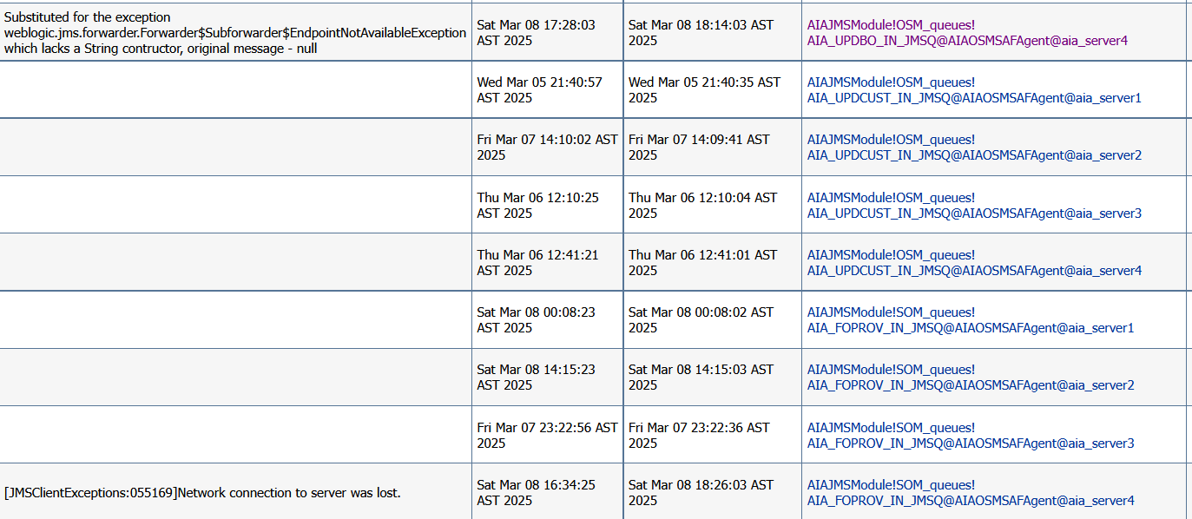

Steps
Step 1:
- Log in AIA PROD weblogic console.
- “Lock & Edit” in change center.
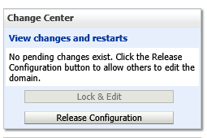

- Go to “SAF”: Home ServicesMessagingStore-and-Forward Agents
- Click on “AIAOSMSAFAgent” MonitoringStatistics
If you see message stuck for all queues on “node 1” then select the SAF agent hosted on node1 i.e.
AIAOSMSAFAgent@aia_server1 – forwarding pause – activate the change and then forwarding resume – activate the change. Same logic applies for other nodes if issue seen on other nodes.

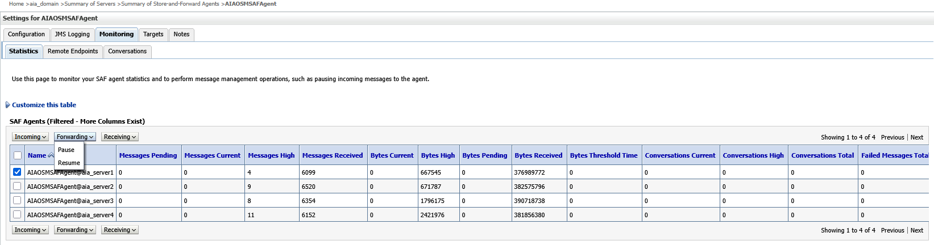

If issue is seen only for 1 Queue for all nodes, then do forwarding - pause and unpause for that queue only on all nodes like below. Here “AIA_CRTFO_IN_JMSQ” for all nodes. Ask OSM to do Consumption pause and unpause the same queue from OSM COM or SOM if it is COM Q or SOM Q from their own Weblogic JMS module:
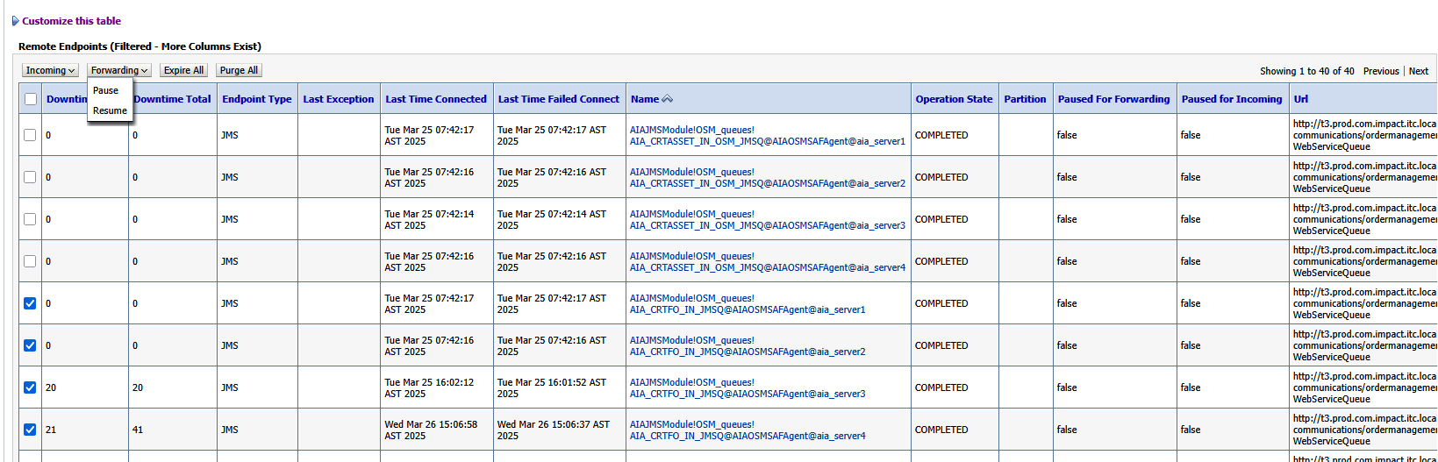

If the issue is seen for 1 Queue and only 1 node like node 1 then do the forwarding - pause and unpause only for that queue for that node only. Here “AIA_CRTFO_IN_JMSQ” for node 1:
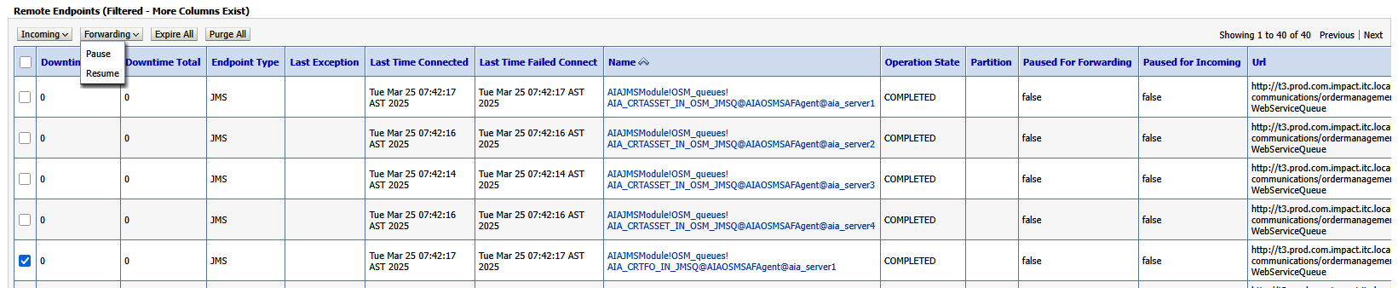
If this doesn’t solve problem then:
Step 2:
Important: Ask OSM SOM to take rolling bounce (rolling restart) 1st and then COM rolling bounce. Then take AIA rolling bounce as per below:
- Login to PRODUCTION AIA WebLogic Console
- Left side, expand “Environment”, click on “Servers”.
- In “Summary of Servers”, click on “Control”.
- Check each “Managed Servers” (MS): “aia_server1” to “aia_server4”.
- For each, click on “Shutdown” and them “Force shutdown now”.
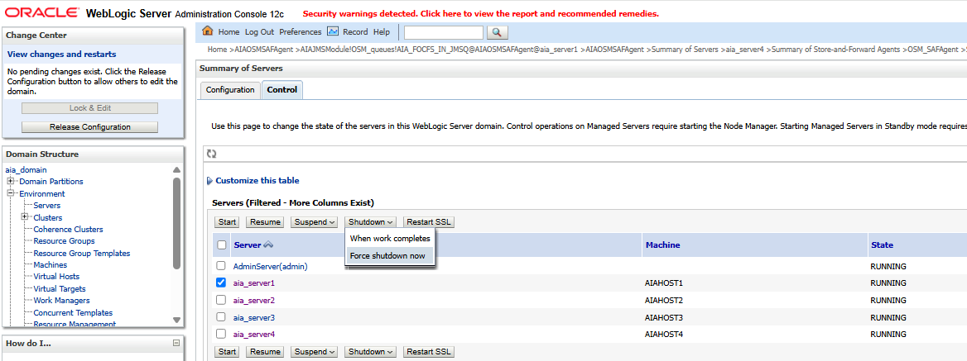
- Confirm “Yes”.
- Once the MS has the "SHUTDOWN" status, check it and click "Start".
- Confirm “Yes”.
- Verify that the MS status is "RUNNING".

SOP2 - Increase the tablespace size when stuck orders occur between AIA and Siebel

Overview
This is a standard operating procedure for increase the tablespace size when stuck orders occur between AIA and Siebel.

Definitions
- AIA DB tablespaces must have free space greater than 40%.

Prerequisites
- The log for the MS "aia_serverX.out" (X is the MS number) shows these errors:
  - Warning threshold "60.0%" crossed for DB allocated space metric

Steps
- Immediately contact the DBA to review the AIA tablespaces.
- He should increase the required tablespace.

SOP3 - Restart of SPM in AIA (AIASessionPoolManager)

Overview
This is a standard operating procedure for restart of SPM in AIA (AIASessionPoolManager) for resume of milestones to Siebel from AIA (final update messages orders to Siebel).

Definitions
- The Session Pool Manager (SPM) is an AIA service that manages a pool of session tokens with Siebel to be reused for subsequent requests.
- The sessions are persisted in memory.
- The login credentials, url of Siebel and endpoint to Siebel are configured AIA Session Pool Manager.
- AIA (process “UpdateSalesOrderSiebelCommsProvABCSImplProcess”) is using “SPM” for send milestones to Siebel (Sync order milestones for orders to Siebel).

Prerequisites
- Orders are not being completed in Siebel because AIA (process “UpdateSalesOrderSiebelCommsProvABCSImplProcess” is sending milestones to siebel by invoking the “SWI_spcOrder_spcUpsert” Siebel service which fails and the update cannot be completed, generating the following error:
- AIA instances allow you manually to execute "Retry" milestones to Siebel from AIA (final update messages orders to Siebel) – process “UpdateSalesOrderOSMCFSCommsJMSConsumer”.
- Below are the different types of errors seen: In AIA log "aia_serverX.out" (X is the MS number) this error should be seen:

- <oracle.integration.platform.blocks.soap> <BEA-000000> <Unable to invoke endpoint URI "https://imp-sbllb.itc.local/siebel/app/eai/enu?SWEExtSource=WebService&SWEExtCmd=Execute&WSSOAP=1" successfully due to: oracle.j2ee.ws.client.jaxws.JRFSOAPFaultException: Client received SOAP Fault from server : Error Code: 10944642 Error Message: Error: Inbound SOAP Message - Session Token is missing or invalid or has expired.>
- <oracle.integration.platform.blocks.soap> <BEA-000000> <Unable to invoke endpoint URI "https://imp-sbllb.itc.local/siebel/app/eai/enu?SWEExtSource=WebService&SWEExtCmd=Execute&WSSOAP=1" successfully due to: oracle.j2ee.ws.client.jaxws.JRFSOAPFaultException: Client received SOAP Fault from server : Error Code: SOAP_ERROR Error Message: Error: Could not create connection to Server. Server is experiencing difficulties.
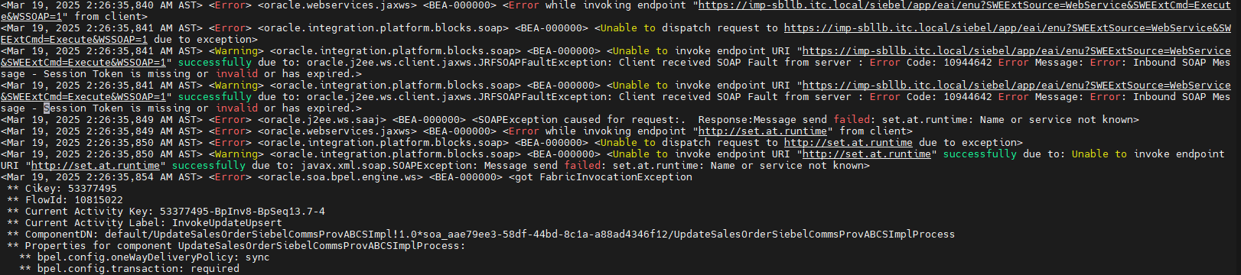

- Although it is a Siebel service issue, to quickly resolve this behavior, the AIASPM (AIASessionPoolManager) in AIA should be restarted.
- Inform Siebel team before restart.
- If the below error is seen.
<Warning> <oracle.integration.platform.blocks.soap> <BEA-000000> <Unable to invoke endpoint URI "https://imp-sbllb.itc.local/siebel/app/eai/enu?SWEExtSource=WebService&SWEExtCmd=Execute&WSSOAP=1" successfully due to: oracle.j2ee.ws.client.jaxws.JRFSOAPFaultException: Client received SOAP Fault from server : Error invoking service 'EAI Siebel Adapter', method 'Upsert' at step 'EAI Update'.(SBL-BPR-00162).
Then Siebel team should check, should be fixed by Siebel only as it should be data issue.

Steps
- Open “SOAPUI” Create “New SOAP Project”
- Insert WSDL: http://imp-aialb.itc.local:8001/soa-infra/services/default/AIASessionPoolManager/client?WSDL
- Change “imp-aialb.itc.local” for each “MS” server:
  - 172.20.10.28
  - 172.20.10.29
  - 172.20.10.30
  - 172.20.10.31
Example: http://172.20.10.28:8001/soa-infra/services/default/AIASessionPoolManager/client?WSDL
- Select “Terminate” operation.
- In the “Request”, edit the payload XML, including the “header” with user, password and token” and “HostId”: SEBL_01:
<soap:Envelope xmlns:soap="http://schemas.xmlsoap.org/soap/envelope/">
<soap:Body>
<ns1: TerminateAIASessionPoolManagerRequest xmlns:ns1="http://xmlns.oracle.com/AIASessionPoolManager">
<ns1:HostId> SEBL_01</ns1:HostId>
</ns1: TerminateAIASessionPoolManagerRequest>
</soap:Body>
</soap:Envelope>
- Execute and view the payload response: Response should be 200.
- Select “Start” operation.
- In the “Request”, edit the payload XML, including the “header” with user, password and token” and “HOST”: SEBL_01:
<soap:Envelope xmlns:soap="http://schemas.xmlsoap.org/soap/envelope/">
<soap:Body>
<ns1:GenericAIASessionPoolManagerRequest xmlns:ns1="http://xmlns.oracle.com/AIASessionPoolManager">
<ns1:HostId> SEBL_01</ns1:HostId>
</ns1:GenericAIASessionPoolManagerRequest>
</soap:Body>
</soap:Envelope>
- Execute for each “MS1, MS2, MS3, MS4” and see the payload response.
- Execute and view the payload response: in response we should see success and initialized sessions count=40
- Execute for each “Managed Server”: 172.20.10.28 through 172.20.10.31.

SOP4 – Restore messages and notifications - OSB Notification Server -

Overview
This is a standard operating to fix different issues with the messages and notification in OSB notifications server with ECE, BRM and OC3C.

Definitions
- Issue is related to ECE not able to produce message
- Issue is related to BRM notifications, OSB is unable to dequeue
- Issue is seen at OC3C or BRM GW not able to consume messages
- Errors connecting to servers seen in OSB log: Full bounce of OSB notification server.

Prerequisites
- The messages and SMS are not sent to customers.
- Inform BRM, ECE and OC3C teams of issue.

Steps

- If the issue is related to ECE not able to produce message, then try below:
  - WebLogic console OSB Notifications server
  - Go to “Home ServicesMessagingJMS Modules Summary of JMS ModulesECE”
  - Click “Production” then “Pause/Resume”.

Note: If that doesn’t work then do take only “Managed Server rolling bounce”, if that doesn’t help then you need “Full bounce” (Detailed at the end of this SOP).
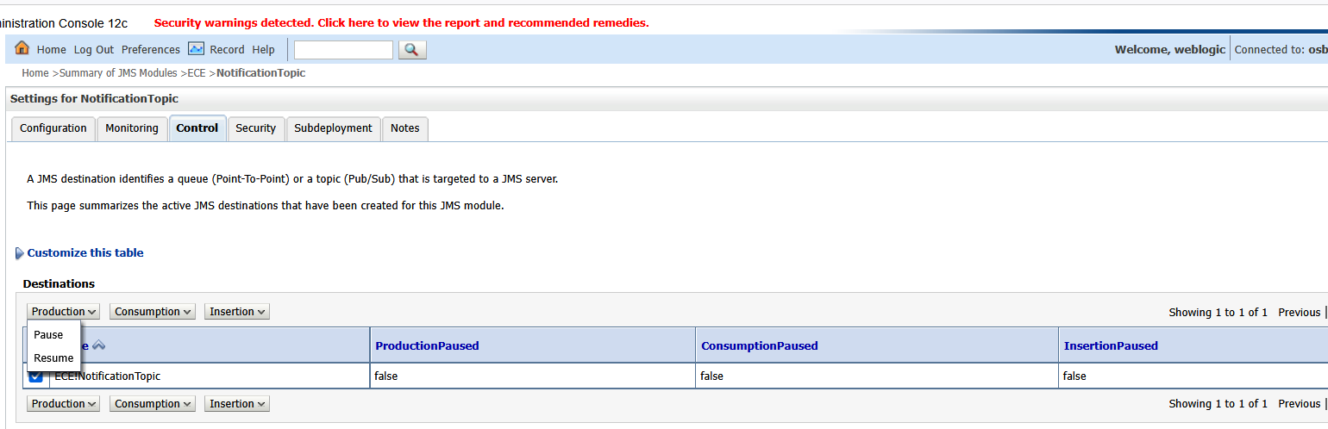
- If issue is related to BRM notifications, OSB is unable to dequeue, then please check the log:
  - if there is error connecting to “Data source”, please compare the “Data Source JNDI” and mapping of the same in “AQ adapter outbound connection pool”.
  - Verify the “JNDI”of “AQ JCA adapter” in BRM notifications proxy service if the same configured in “AQ Adaptor outbound connection pool” on weblogic.
  - If all settings are correct then try below options:
    - Ask BRM team to disable “dequeue” and “enable” back again.
  - If this doesn’t work, then try below.
    - Restart the data source of “BRM AQ adapter” used for connecting to BRM DB.
    - Go to “Home Services Data Sources BRMDataSource Control”
    - Do 1 by 1 stop and start on each server.
      - For stop click “Force Shutdown”.
      - For start click “Start”.

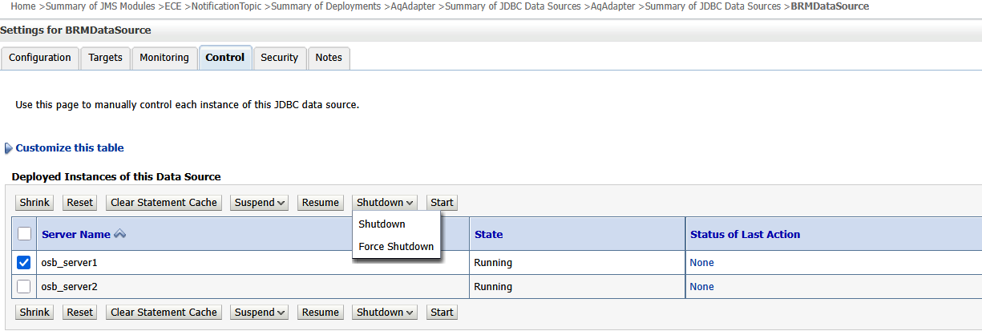

    - Restart the AQ Adapter (AqAdapter) seen on Weblogic deployment.
      - Go to “Home Deployments Summary of Deployments AqAdapter
      - Click “ControlResource Adapter”
      - Click “Stop” and select “Force stop now”
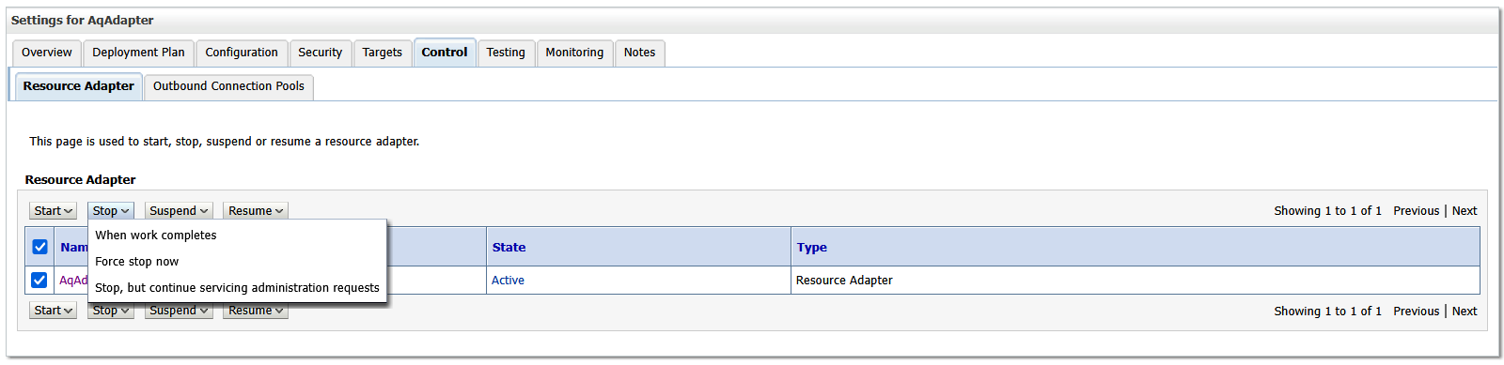

      - Once state is seen stopped, please click on “Start” and “Servicing all requests”

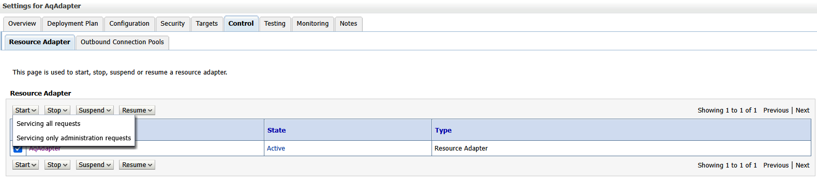
      - Now state should be seen back “Active”
  - if this doesn’t work, then try below:
    - Log in to OSB service bus console.
    - Go to BRM notifications API.
    - Go to “ProxyServices” for each notifications and do below (this should be done mostly in case if the issue seen only for selective BRM notifications).
    - Create “Session” and do uncheck the below box, activate it.
    - Then create one more session and do check the below box again, activate it.
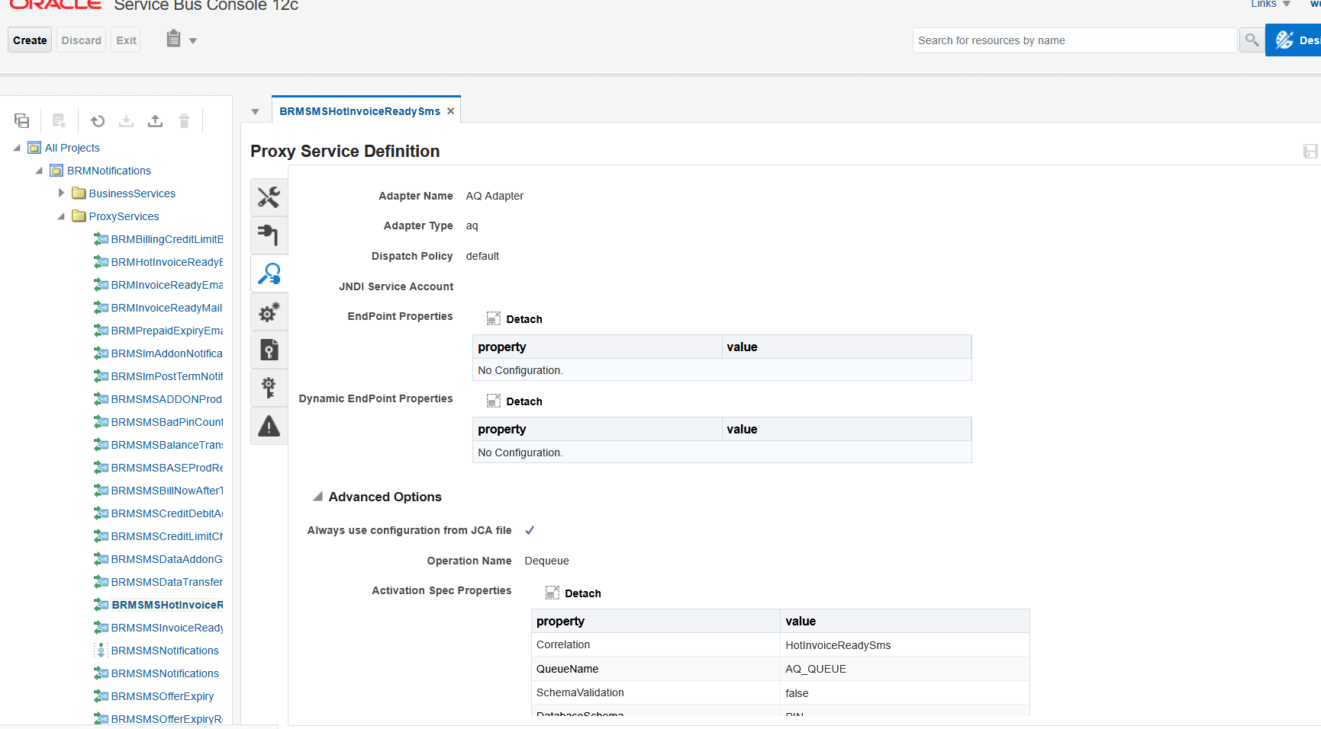

- If issue is seen at OC3C or BRM GW not able to consume messages:
  - Check the respective topic or queue if subscription state “false”.
  - if seen “false” then no action on OSB, so OC3C or BRM GW should check their log.
  - If the connection properties having right details matching with OSB, if all good then OC3C or BRM GW should take rolling bounce to restore the service for them.
  - BRM GW and OC3C consumes messages from below. If the highlighted column value seen as “false” instead of “active” then it is BRM GW and OC3C issue.
    - Go to JMS modules : ECE NotificationTopic (consumers = BRM GW , OC3C)
    - Go to JMS modules : ECE NotificationTopic Monitoring Durable Subscribers (This is topic, consumers = BRM GW , OC3C), SuspenseQueue (this is JMS Q, consumer I think OC3C)
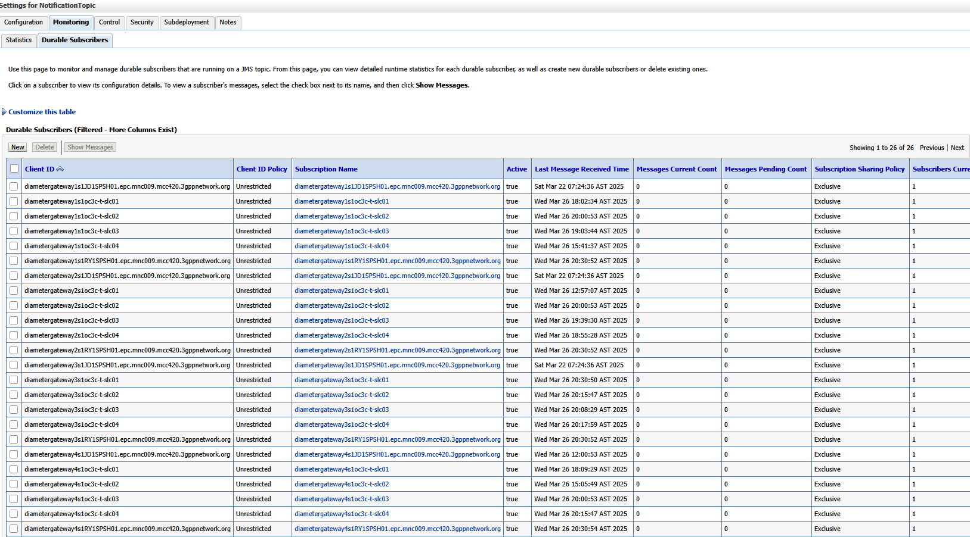

    - Go to “JMS Modules Semati_IB_JMSModule BRMNotificationTopic Monitoring Durable Subscribers
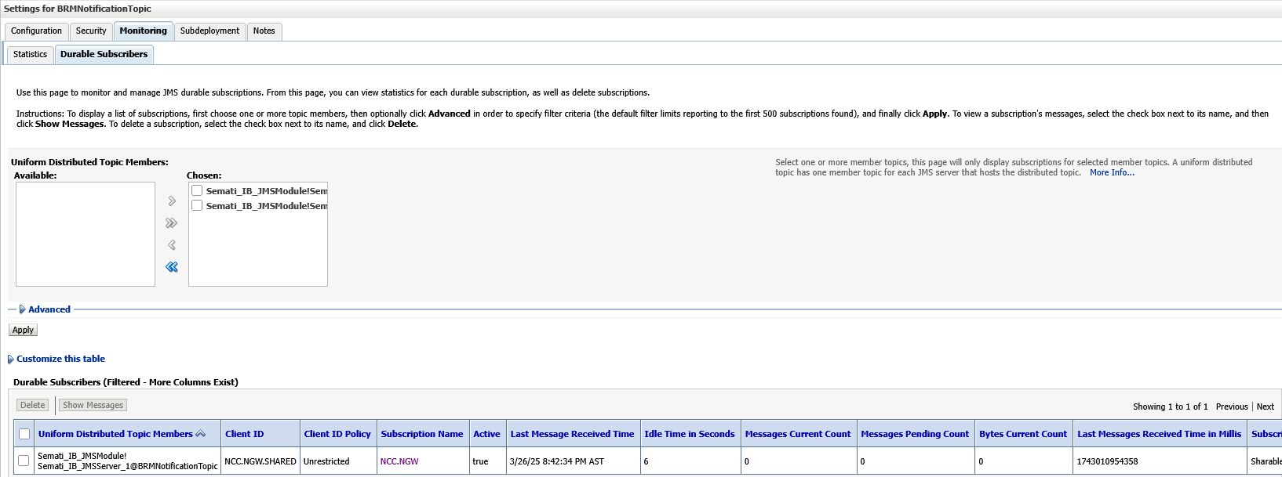

    - Go to “JMS Modules Semati_IB_JMSModule SiebelNotificationTopic Monitoring Durable Subscribers (Topic , consumer= OC3C) , subscription state if seen “false” then OC3C needs restart.
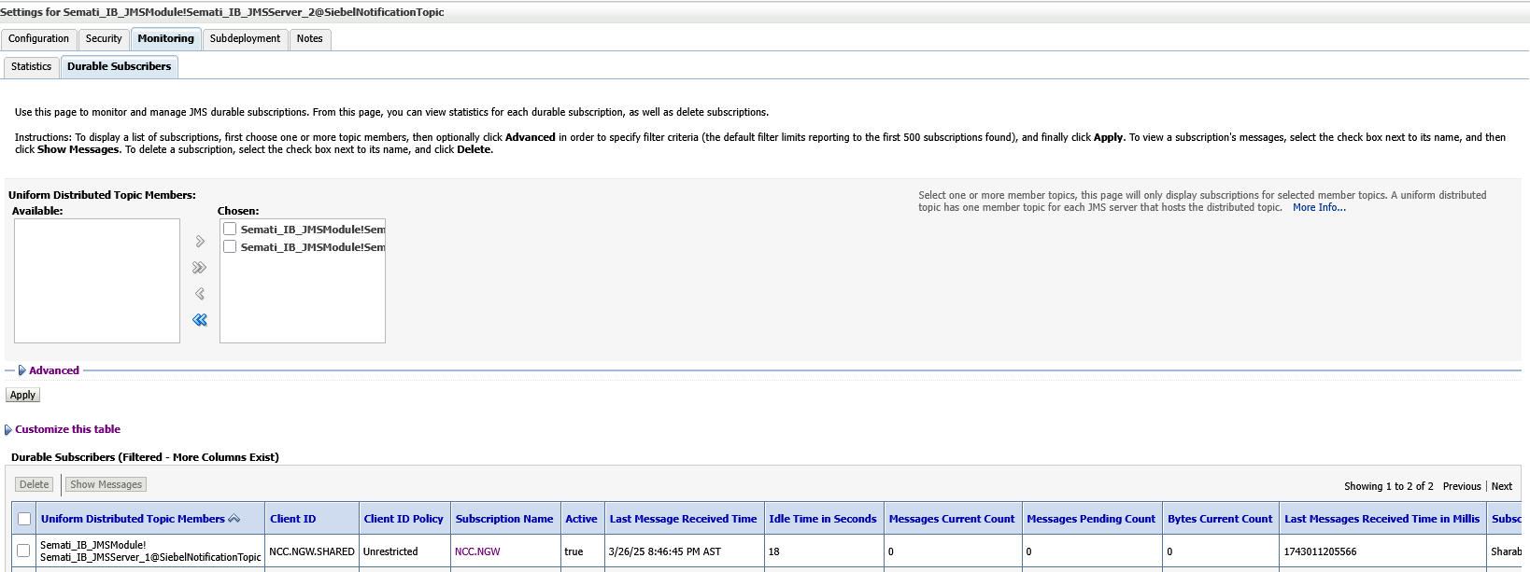

- This should be followed only if errors connecting to servers seen in OSB log or if the above fixes don’t work. Then take full bounce of OSB notification server.
  - RESTART (full bounce):
    - Shutdown MS1, MS2 and AdminServer from Production WebLogic console
    - Admin from console
    - Take backup “tmp” and “cache” from MS1, MS2 and AdminServer
      - MS1: Go to /app/oracle/fmw_domains/mserver/osb_domain/servers/osb_server1
      - MS2: Go to /app/oracle/fmw_domains/mserver/osb_domain/servers/osb_server2
      - Admin: Go to /app/oracle/fmw_domains/aserver/osb_domain/servers/AdminServer
        - mv tmp tmp_bkp_mmddyyyy
        - mv cache cache_bkp_mmddyyyy
    - ps -ef | grep java
Should able to see “Nodemanager” process only or OEM process also
    - Restart Node manager: Go to /app/oracle/fmw_domains/mserver/osb_domain/bin
- shutdown nodemanager: ./stopNodeManager.sh
- start nodemanager: nohup ./startNodeManager.sh &
    - ps -ef |grep java
Should have nodemanager process
    - start Admin server: Go to /app/oracle/fmw_domains/aserver/osb_domain/bin
- nohup ./startWebLogic.sh &
- tail -f nohup.out
Wait for Admin server state change to RUNNING
    - Go to admin console
    - Start MS1 & MS2 together: wait until the state RUNNING
  - POST RESTART:
    - Check for Server state & health from WebLogic console:
Home Servers
    - Check for Deployments should be 'Active' from WebLogic console:
Home Deployments
    - Check for JMS Subscribers should be in 'true' from WebLogic console:
Home ServicesMessagingJMS Modules Summary of JMS Modules
  - Modules:
      - ECE: NotificationTopicMonitoringDurable Subscribers:
NotificationTopic - BRM gateway, OC3C NGW and ECE subscribers
      - Semati_IB_JMSModule:
BRMNotificationTopicMonitoringDurable Subscribers - OC3C NGW
SiebelNotificationTopicMonitoringDurable Subscribers - OC3C NGW

Important note for other systems after the Server restart
- If OSB Admin server is restarted then BRM gateway, ECE needs to be restarted.
- If OSB Managed server is restarted then OC3C needs to be restarted.
- If OSB Full restart (full bounce) is performed then BRM gateway, ECE and OC3C needs to be restarted.

SOP5: Main OSB MS Server Rolling or Full bounce.

Overview
This is a standard operating to execute OSB Managed Servers Rolling or Full bounce

Definitions
OSB is service bus integration for Salam and 3PP systems including Oracle RODOD stacks for digital flows. This is to take care of rolling or full bounce to restore the service.

Prerequisites
In case of full bounce – channels will be impacted – hence channels should have maintenance window during the approved time.

Steps
- This should be followed only if errors connecting to servers seen in OSB log or if any weblogic resource connectivity errors seen or if any weblogic deployment is failed or if any queue having incorrect consumers count etc, which are not getting fixed by below steps.
  - 1st level fix which should be applied:
If we see error seen related to min or max connection pool size exhausted or doesn’t have enough connections on any weblogic resource like data source or JMS resource etc then increase the connection pool size for the same and restart the resource.
Example:
- Go to “Summary of JDBC Data Sources OSB_DB Connection pool.
- Increase the below and take restart of the data source:
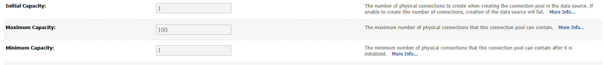
- Go to “Control” of data source.
- Click “Force Shutdown” and then start 1 by 1.
- Validate if state back to “running”. Now validate the log and transactions if working.
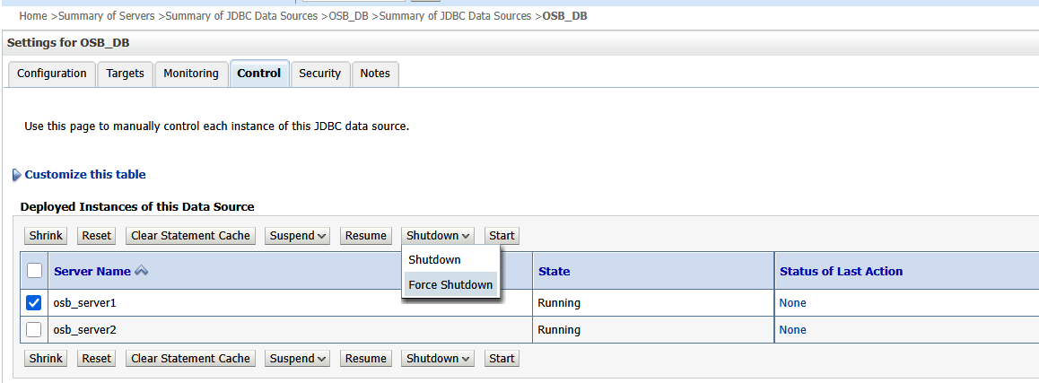
- If issue is seen JMS consumer API is not consuming messages from a JMS Q on both the node then validate the JMS JNDI if correct – if do consumption pause/unpause for the same Q if there is no issue seen in producing messages in to the same Q.
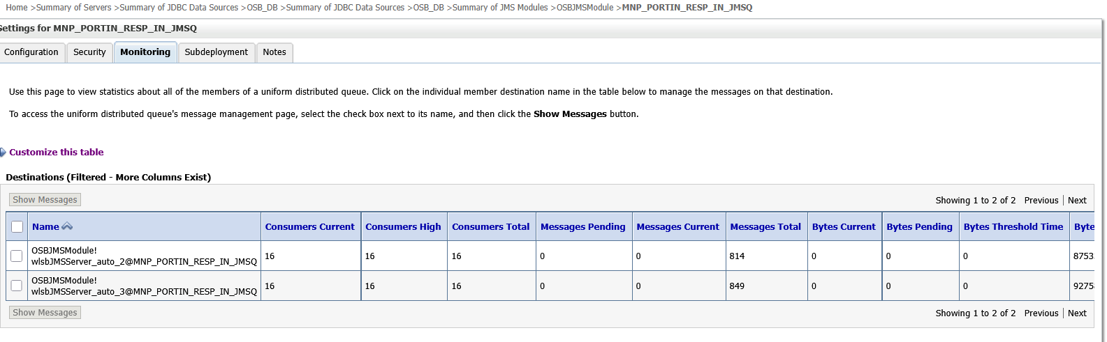
Go to “JMS Servers” and go to that specific JMS server once on node 1 , then on node 2. In each of the case go to monitoring / Active Destinations and select the Q – do consumption pause and unpause – do the same on other node as well.
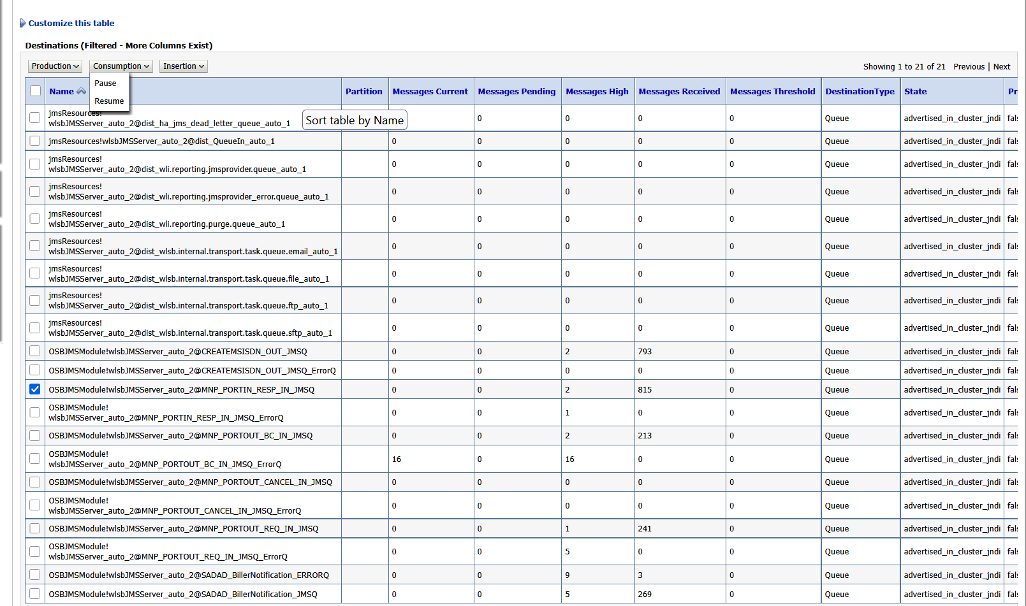
- If issue is seen that consumer current count doesn’t match between the nodes and consumer is able to consume message from 1 node but not from another node. Then do the above option pause/unpause the JMS Q on the impacted node, if it doesn’t work then log in to OSB service bus console- take back up of the consumer API and then delete it, then deploy it back.
  - Take back up using below.
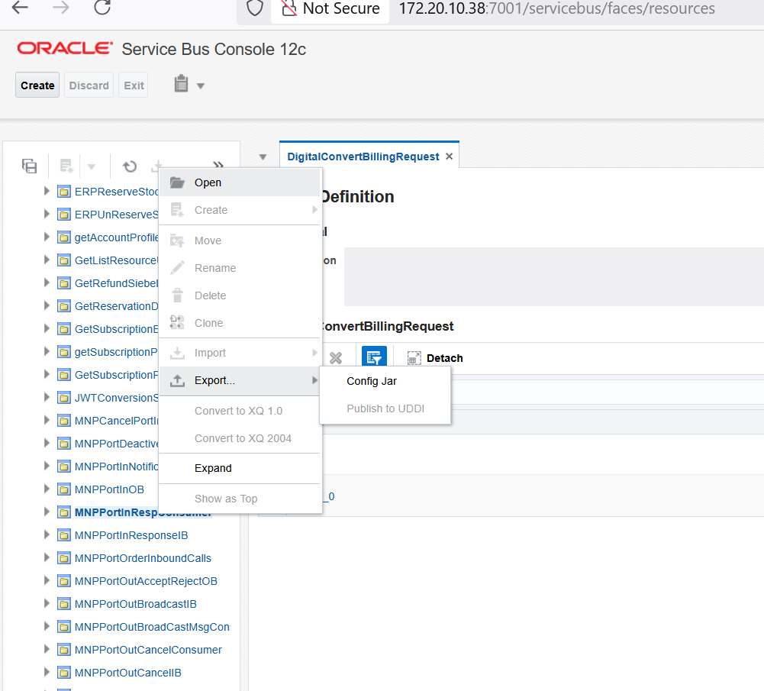
  - Create a session and do right click, select “delete” option below and then do “click activate”.
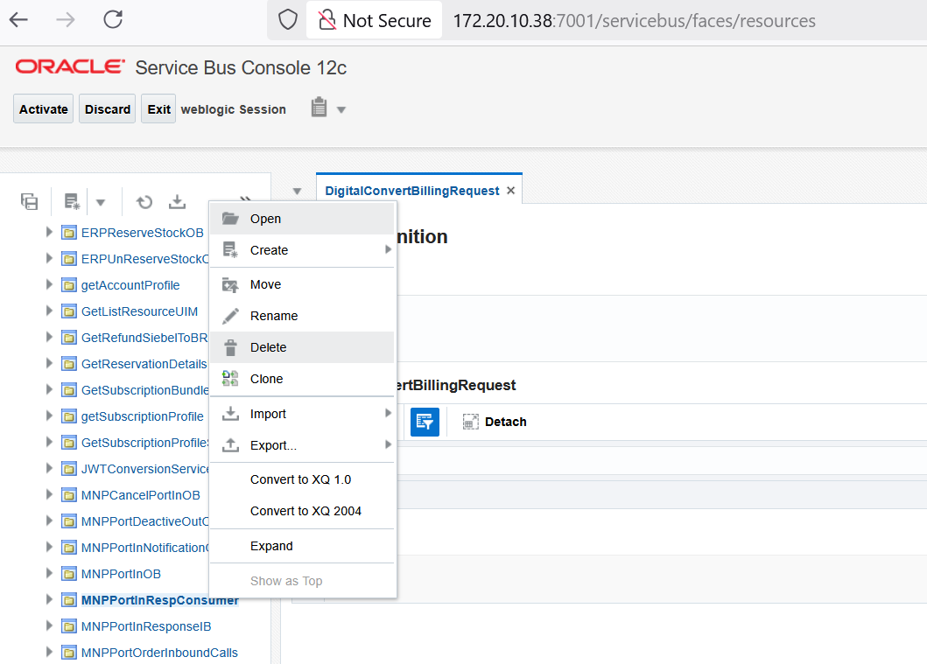
  - Create a session below and do import the back up jar and activate the session.

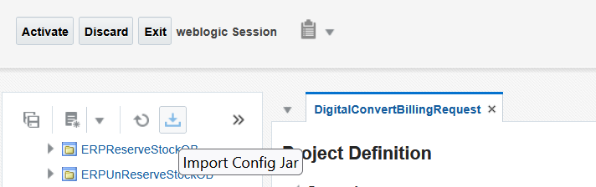

NOTE: If this doesn’t work then do take rolling bounce clearing tmp, cache – if that doesn’t work then take full bounce.
- Rolling Bounce (restart) procedure:
  - Login to PRODUCTION AIA WebLogic Console
  - Left side, expand “Environment”, click on “Servers”.
  - In “Summary of Servers”, click on “Control”.
  - Check each “Managed Servers” (MS): “osb_server1” to “osb_server2”.
  - For each, click on “Shutdown” and them “Force shutdown now”.
  - Confirm “Yes”.
  - Once the MS has the "SHUTDOWN" status, check it and click "Start".
  - Confirm “Yes”.
  - Verify that the MS status is "RUNNING".
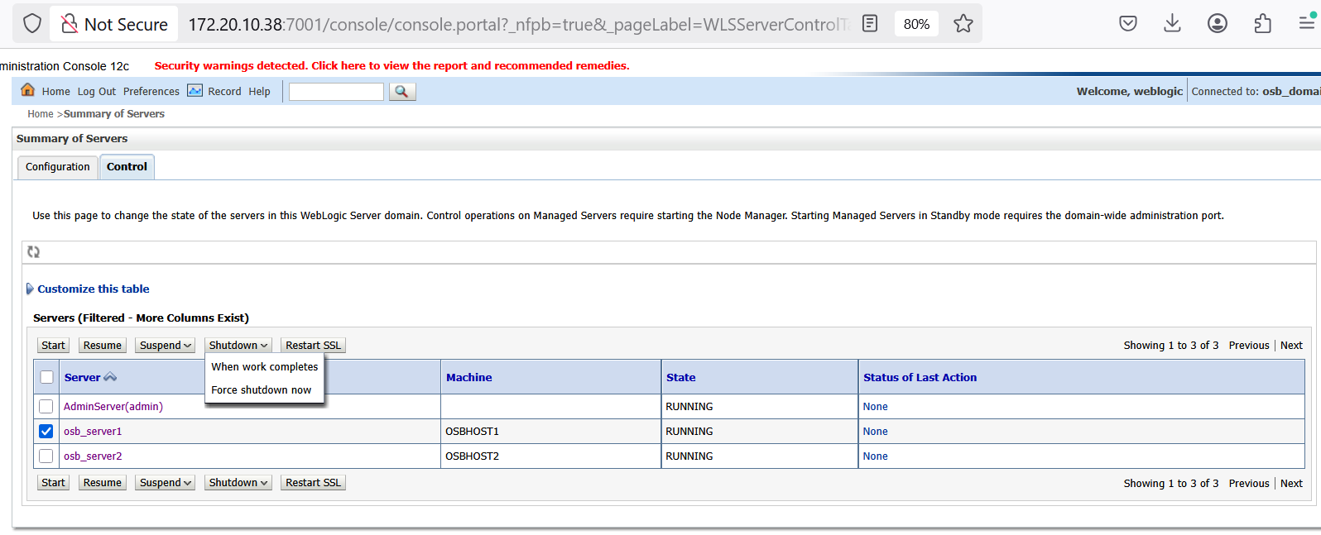

- Full Bounce:
  - Shutdown MS1, MS2 and AdminServer from WebLogic console (http://172.20.10.38:7001/console)
  - Admin from console
  - Take backup “tmp” and “cache” from MS1, MS2 and AdminServer
  - MS1: Go to /app/oracle/fmw_domains/mserver/osb_domain/servers/osb_server1
  - MS2: Go to /app/oracle/fmw_domains/mserver/osb_domain/servers/osb_server2
  - Admin: Go to /app/oracle/fmw_domains/mserver/osb_domain/servers/AdminServer
    - mv tmp tmp_bkp_mmddyyyy
    - mv cache cache_bkp_mmddyyyy
  - ps -ef | grep java
Should be able to see nodemanager process only or OEM process also
  - Restart Node manager: Go to /app/oracle/fmw_domains/mserver/osb_domain/bin
  - shutdown nodemanager: ./stopNodeManager.sh
  - start nodemanager: nohup ./startNodeManager.sh &
  - ps -ef |grep java
Should see nodemanager process only or OEM process also.
  - start Admin server: Go to /app/oracle/fmw_domains/aserver/osb_domain/bin
- nohup ./startWebLogic.sh &
- tail -f nohup.out
Wait for Admin server state change to RUNNING
  - Go to admin console
  - Start MS1 & MS2 together: wait until the state RUNNING
Post restart:
- Check for Server state & health from WebLogic console: Home Servers
- Check for Deployments should be 'Active' from WebLogic console: Home Deployments

11. Post-Restoration Procedures
Once the service is restored, the following steps should be completed:
- Monitor the Service: Continue monitoring the orders in AIA / OSB / OSB Notifications to ensure that the issue doesn’t recur.
- Update the Incident Ticket: Document the solution, time to resolution, and any follow-up actions required.
- Communication: Inform all stakeholders that the service has been restored, along with any relevant information.
- Root Cause Analysis: Conduct a post-incident review to determine the root cause and whether any changes or preventive measures are needed.
- Document the Process: Review the restoration process, noting any improvements or adjustments to the SOP that should be made.

12. Copyright Information

Intellectual Property
Copyright 2023-2024 Salam. All rights reserved.
The following documentation, the content therein and/or the presentation of its information is proprietary to and embodies the confidential processes, designs, technologies and otherwise of Salam. All copyright, trademarks, trade names, patents, industrial designs, and other intellectual property rights contained herein are, unless otherwise specified, the exclusive property of Salam.
The information (including, but by no means limited to, data, drawings, specifications, documentation, software listings, source and/or object code) shall not be disclosed, manipulated, disseminated or otherwise in any manner inconsistent with the nature and/or conditions under which this documentation has been issued.
The copyright herein is expressly protected at common law, statute and under various International and MultiNational Treatises (including, but by no means limited to, the Berne Convention for the Protection of Literary and Artistic Works).

Disclaimer
Information and specifications in this document are subject to change without notice. Salam may have patents, patent applications, trademarks, copyrights, or other intellectual property rights covering subject matter in this document. Except as expressly provided in any written license agreement from Salam, the furnishing of this document does not grant any license to the patents, trademarks, copyrights, or other intellectual property covering the subject matter enclosed, herein.
Unless otherwise noted, the example companies, organizations, products, domain names, e-mail addresses, logos, people, places, and events depicted herein are fictitious, and no association with any real company, organization, product, domain name, e-mail address, logo, person, place, or event is intended or should be inferred. The names of actual companies and products mentioned herein may be the trademarks of their respective owners.

Salam
Address: Commercial Building, Almuraba’ Street, 5th floor, Application sector – Information Technology
Web: www.Salam.sa

